Installing NetHunter

Section 2, Lecture 6

Now that we have a root account on the device, all we need to do is install NetHunter, this step will take some time so be patient.

1. Download NetHunter **to your Android device** from [this page](https://www.offensive-security.com/kali-linux-nethunter-download/), make sure you open the page using you Android device not PC and download an image comparable with your software, to see your device software go to settings >> about this device.

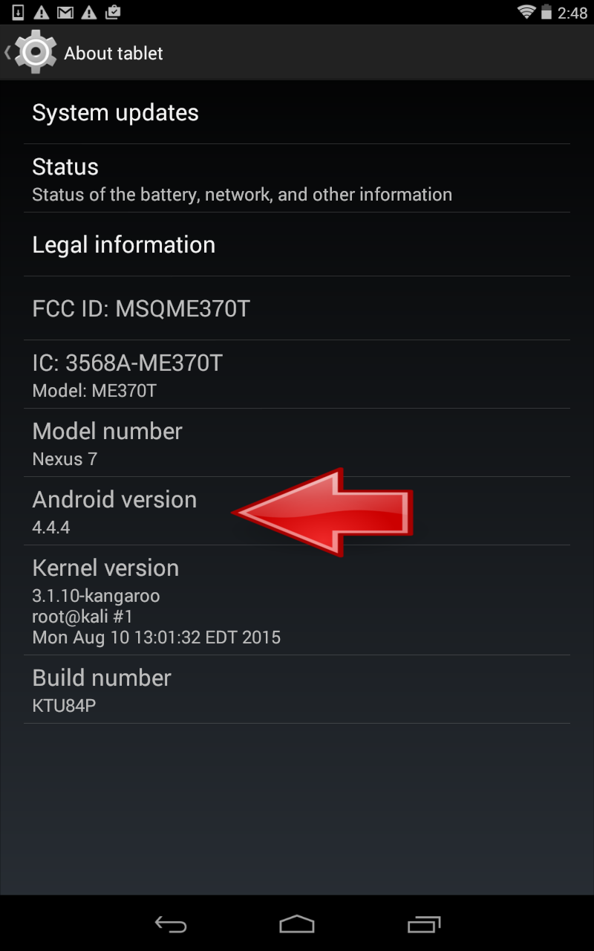

The image will be stored into your downloads directory on the Android device.

2. Now you need to reboot your device into recovery and install NetHunter, you can reboot into recvery using the nexus root toolkit by going to *Advanced Utilities > Reboot Recovery,*or you can do this manually, firs power off your device, once its off hold down the power and volume down buttons at the same time until you see an android logo on the screen.

3. Press the volume down twice now, the message on the screen will change and it will say "Recovery Mode" now, press the power button to enter recovery.

4. Press on Install, then navigate to where you downloaded the Kali image, select the zip file and swipe to confirm the process.

Now this might take some time, once the installation process is finished you can reboot into NetHunter.